American Association of Settlement Consultants
Virtual Conference
December 4 & 5, 2024

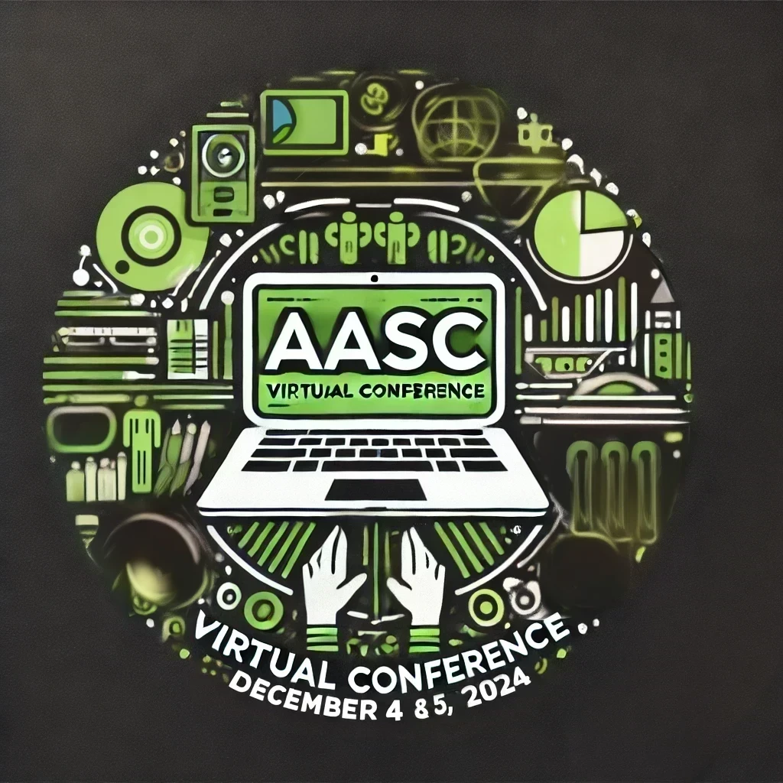

Wednesday, December 4

12:00-12:05pm Welcome Joanna Wynes

12:05-12:55pm Market-Based Structured Settlements Josh Farmer
Joe DiGangi
Brian Schachter

12:55-1:00pm Break

1:00-1:50pm Moral Matters: Ethical Dilemmas in Structured Settlements Marcy Espinoza-Hanson Chad Ettmueller

1:50-2:20pm Initial Client Meeting: Building Trust and Understanding Needs George Audi

2:20-3:00pm Holistic Settlement Planning for Consultants for Client Success Jake Duvall
Joe Tombs
Shannon Laymon-Pecororo

December 5, 2024

12:00-12:05pm Partner Member videos

12:05-12:30pm What's happening at the AASC? Joanna Wynes
Brian Schachter
David Vaclavik
Randy Levine Colin Finn

12:30-1:20pm Optimizing Settlement Dollars: Leveraging Diverse Jake Duvall
Investment Products for Maximum Results Joe Tombs
Shannon Laymon-Pecororo

1:20-1:25pm Break/Partner videos

1:25-1:30pm Reflections & Updates Joanna Wynes

1:30-1:35pm Partner videos

1:35-2:05pm Insights from the Experts: An Interactive Q&A for New Consultants Louis Masry
Taylor Alexander
Len Blonder

2:05-3:00pm Mastering Complex Settlements: Navigating Tax Challenges Robin Wood
and Resolving Disputes between the structured settlement Scott Freeman
providers and the attorneys involved in the case Kristin Neerhof

Subjects listed in bold are being pursued for continuing education credits.

